LKMaps Desktop Version 2.0.0

12th May, 2023

Table of Contents

ACKNOWLEDGEMENT TO TONINO TARSI:- 2

POSSIBLE ISSUES:- 2

NEW FEATURES in Version 2:- 3

HELP:- 3

Purge App Data Folders:- 3

HOW TO USE LKMAPS DESKTOP SOFTWARE:- 4

Information Boxes and Slide Adjusters:- 4

Moving around the Display Map:- 4

How to select your map area:- 4

Action Buttons:- 4

OPEN SOURCE LICENCE:- 5

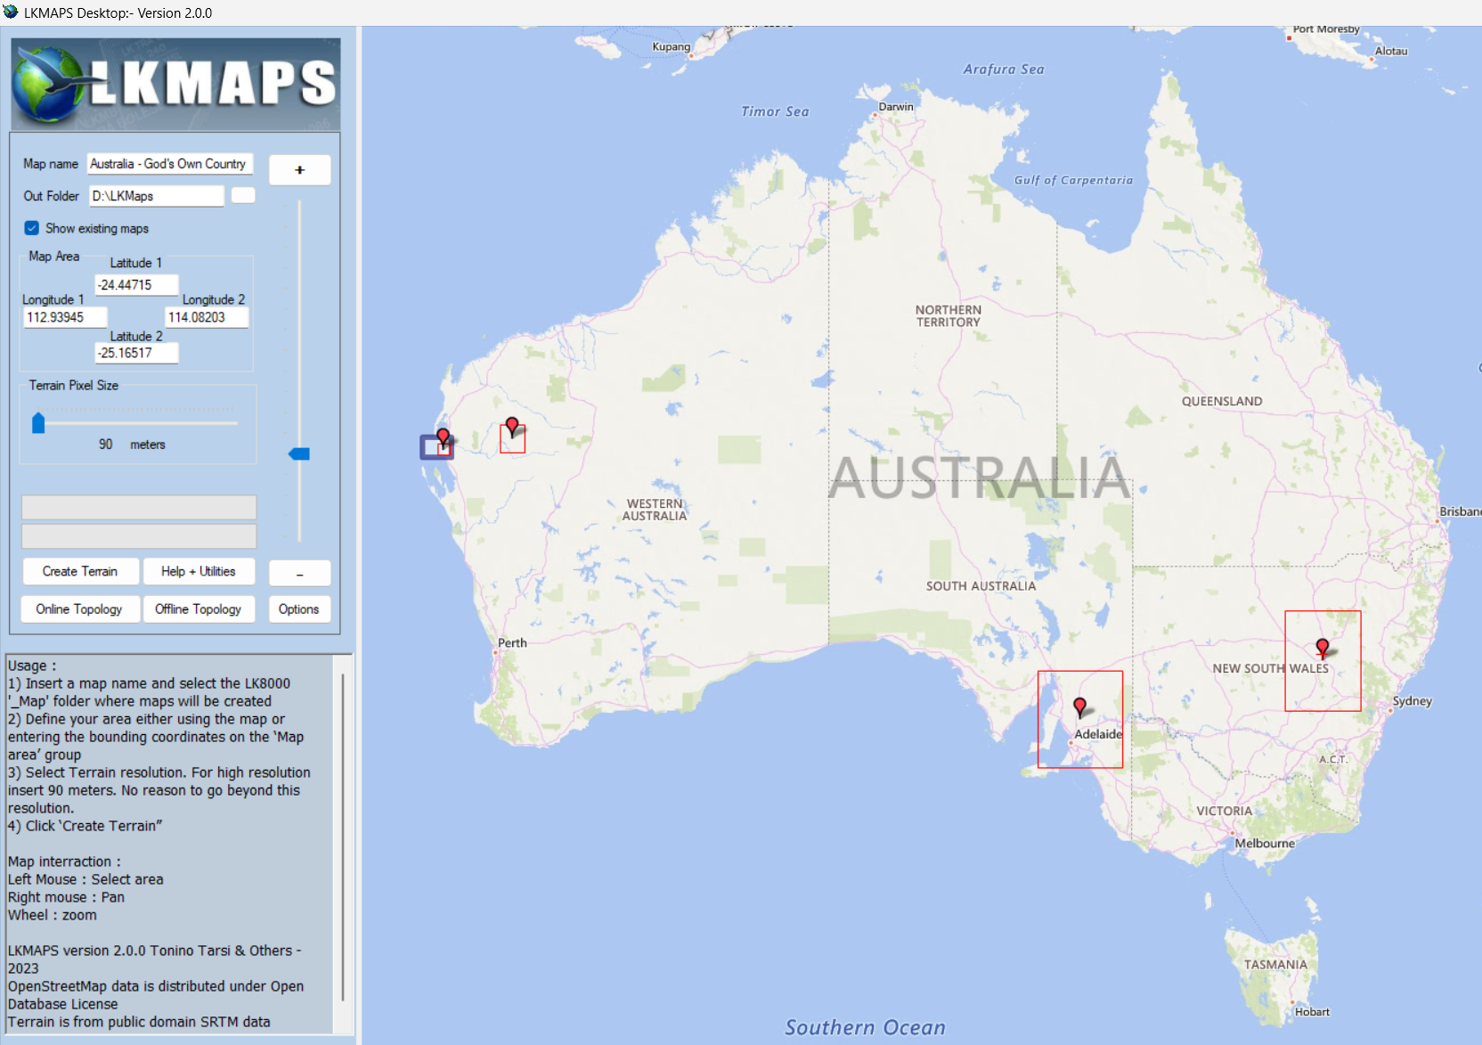

# ACKNOWLEDGEMENT TO TONINO TARSI:-

Sincere acknowledgement must be given at the start of this documentation to Tonino Tarsi for the incredible amount of work he put into developing LKMaps Desktop. My contribution has been to update a small part of the code to solve a few issues that have crept in over time as the Digital Terrain Model access method and OpenStreetMaps data processing requirements changed.

# POSSIBLE ISSUES:-

1. **Creating Terrain**:- When downloading Digital Elevation Model data in the original version of **LKMaps Desktop**, the software sometimes “hung” at the Mosaicing stage with the progress bar at about 40%. If this still happens to you with this version, please share it in the GitHub Issues webpage for LKMaps Desktop with details of how you managed to produce the error, and I will address it immediately.

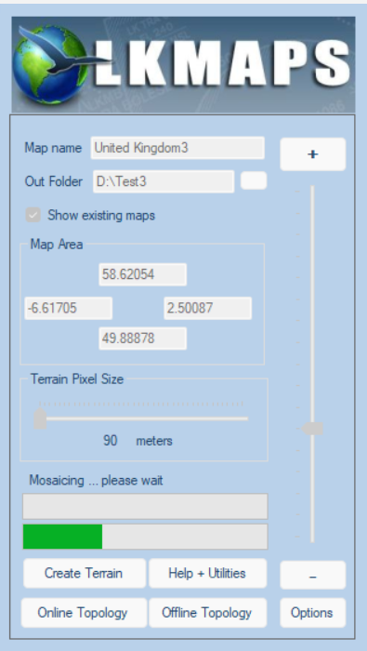

1. A screenshot of a computer error

   Description automatically generated with medium confidence**Online/Offline Topology**:- In the original version of **LKMaps Desktop** the “Line Number” stopped increasing past a certain number. This is now error trapped, and you be notified with this warning message. Usually, a reboot of your computer will resolve this GDAL processing error. If a reboot fails to solve the issue, please let us know by sharing it in the GitHub Issues webpage for LKMaps, and I will address it immediately.

# NEW FEATURES in Version 2:-

I am testing a different method of generating **Online Topology** which may improve performance and reliability. This uses the OSMConvert utility to do some translation of data which seems to help. Further testing by users will see if this is borne out in practice.

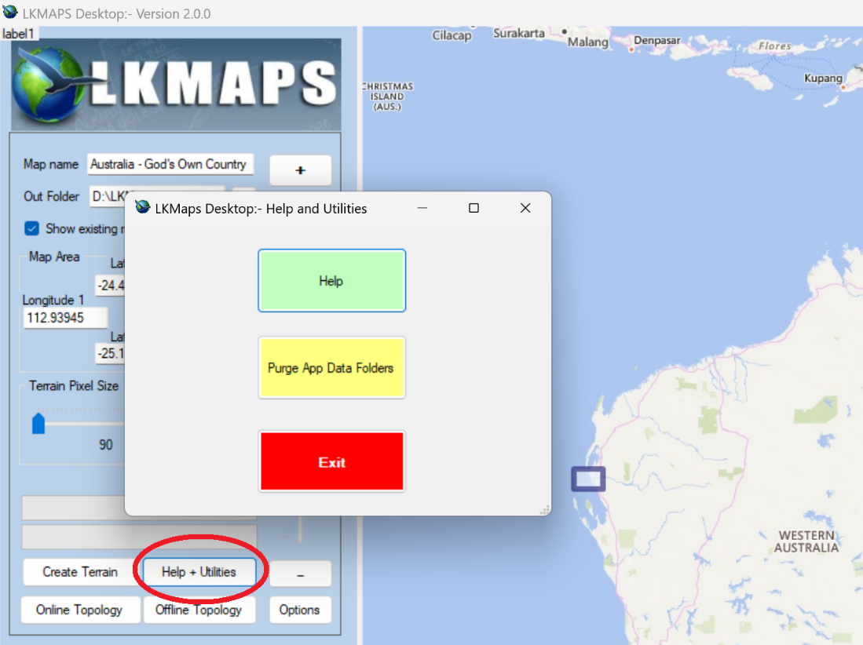

# HELP:-

A manual is being developed to explained the various procedures available in LKMap Desktop. Click on the **Help + Utilities** on the main screen to access the HELP button.

# Purge App Data Folders:-

If you have problems with the software for any reason, it may help if the \AppData\Local\LKMAPS are purged/cleaned up by clicking on the **Purge App Data Folders** button. If you have a problem, give it a try. Rebooting your computer may also help after this is done to clear any unwanted cached date.

# HOW TO USE LKMAPS DESKTOP SOFTWARE:-

## Information Boxes and Slide Adjusters:-

* **Map Name:-** This is the name you would like to give you map. Use a name which will make sense to you for the area convered by the map.
* **Output Folder:-** Click the small box to the right of the Output Folder lable to select the folder your maps will be stored in. If you always use that folder, your previously generated maps will show on the screen if you have the **Show existing maps** checkbox selected.
* **Latitude 1 and Latitude 2:**- Enter the North/South latitudes that will define you map’s boundaries. The latitude entries can go in either latitude box as they will be automatically arranged by the software.
* **Longitude 1 and Longitude 2:**- Enter the North/South latitudes that will define you map’s boundaries. The longitude entries can go in either latitude box as they will be automatically arranged by the software.
* **Terrain Pixel Size:**- Modern navigation devices can easily handle the map size generated by a 90 metre pixel size. There is little benefit in increasing the pixel size.
* **Plus/Minus buttons and Slider:**- These adjust the map zoom. You can also use the mouse wheel to zoom the map.

## Moving around the Display Map:-

* Hold down the RIGHT mouse but to drag the map.
* Use the mouse WHEEL to zoom in and out. You may also use the + and – buttons on the programs left side too.

## How to select your map area:-

**There are two options:-**

1. Use your mouse to draw a geographical box around the map area you require. To do this, **LEFT CLICK** the mouse, draw your box, then **LEFT CLICK** the mouse again. You will now be given the option of **Yes** to accept the drawn box, or **No** to abort the process. The latitude and longitude boundaries of your map box will be automatically generated for you.
2. You may manually enter the Latitude and Longitude positions for the top left and bottom right of the are you wish to create a map for. The software will arrange the correct Latitude maximum/minimum and Longitude maximum/minimum values for you automatically.

## Action Buttons:-

* **Create Terrain:-** This will create your maps .DEM file, (**D**igital **E**levation **M**odel). This should only take a few minutes to complete.
* **Online Topology:-** Topology is downloaded from the **OpenStreetMaps** Overpass Server. For larger areas such as the whole of the United Kingdom, the amount of data required will probably exceed 1 gigabyte, so consider just how big an area your map really need to cover. You will be warned if the maps are a little large. The download process should succeed, but if you are creating several maps for a particular country or geographic area, it may be best to use the Offline method detailed below.
* **A screenshot of a computer error message

  Description automatically generated with medium confidenceOffline Topology:-** Using the Offline Topology process may be more efficient when you wish to create a number of maps in a single country or one that covers a large area. If you have not already downloaded an OpenStreetMap .osm.pbf file for the required area previous, select “Yes, and you will be taken to the <http://download.geofabrik.de> website to select your download. If you have previously completed the download, click No, and you will then be able to select the .osm.pbf file of your choosing for the map area required.

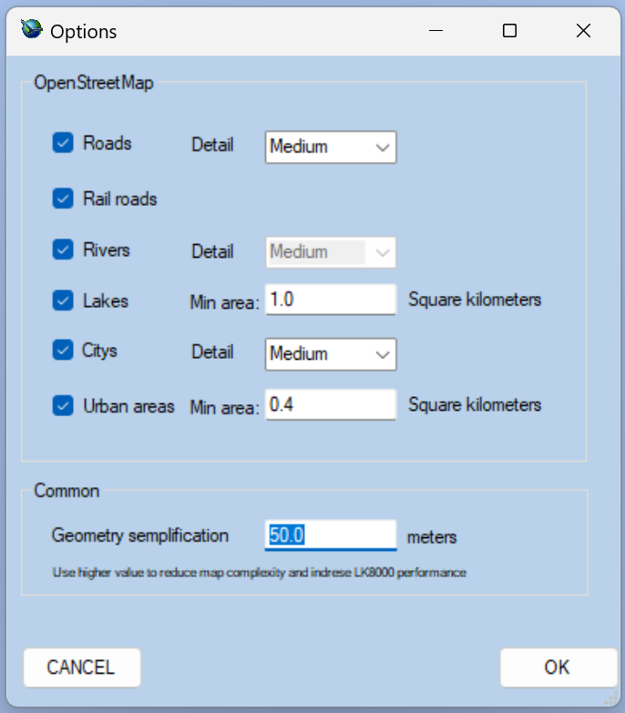**Options:-** These are the standard Options for the OpenStreetMap data. Increasing the level of any item will also increase the volume of data required. This can make large map files very large indeed, so use some caution if you have a lower powered navigation device.

# OPEN SOURCE LICENCE:-

(To be continued….)